Vocabulary Guide:
Going to the doctors

Covid–19 INFOMATION:
The main symptoms of Covid-19 are:
- A high temperature – This means you back or chest is very hot when you touch it.
- A new, continuous cough – This means you are coughing a lot more than normal, or 3 coughing episodes in 24 hours.
- A loss or change of you taste or smell – this means you cannot smell or taste anything, or things smell or taste different to normal.
If you have any of these symptoms:
- Get a Covid-19 test as soon as possible.
- You and people you live with need to stay home and nobody can visit until you have the results.

For more information about Covid-19 please look at the NHS website:
https://www.nhs.uk/conditions/coronavirus-covid-19/symptoms/#symptoms

Why might you go to the doctors?
If you are in pain: a feeling if you have been hurt or if you are ill (sick)

If you have an ache: A pain that will not go away.
- Examples - I have stomachache.

If you are feeling sick - physically sick or mentally sick
- Examples – I have stomachache, I think I might be sick.

If you are feeling ill – you have an illness and not feeling very well (sick)
- Examples – I am ill so I will not be able to come to work today.

If a part of your body feels sore: It could hurt, and it may look red.
- Example - I have a sore throat.

If you have a temperature: If your body is too hot or too cold.
People normally have a temperature when they have an illness.
- Examples – I feel very weak and too hot, I think I have a temperature.

If you have a fever: when someone has an illness and have a high temperature.
- Examples – I am very hot I think I have a fever.

When you have a wound: an injury where a hole is made in the skin.
- Example - There wounds did not seem very serious.

When you have a cut: this is a wound usually caused by something sharp.
- Examples – They cut his finger using the scissors.
They have a deep cut on her arm.
When you have a bruise: a brown, blue or purple colored patch on your skin that you can get after you hit something hard.
- Examples – They fell off their bike and got a big bruise on his knee.

How to book an appointment at the doctors:
Receptionist: | You:
Good morning, can I help you please? | - I would like to make an appointment...  - I want to make an appointment.  - I need to make an appointment.  - Can I make an appointment?  - May I make an appointment?  - Would it be possible to make an appointment? | To see  To talk to | A doctor  A Nurse | Please?

Think about what day you would like to see the doctor:
Receptionist: | You:
When would you like to book your appointment for? | Can I have an appointment for … | - Today...  - Today, it is urgent...  - Tomorrow morning...  - Tomorrow afternoon...  - Next week... | Please?
Things you might say if there is an appointment for the day you would like:
Receptionist | You
Yes, we can book you in for that day, we will see you soon. Goodbye | - Thank you see you soon.  - Thank you for your help.

Things you might say if they cannot book you in for the day you want:
Receptionist | You | Receptionist: | You:
I am sorry but we cannot book you in for that day.  Would you be available on a different day? | - Yes, I will be able to come in:  - Today  - Tomorrow  - Any day this week  - Next week  - No, I am sorry, but I cannot do another day. | We can book you in for then.  Okay, let me speak with the Doctor...  It looks like we can get you in. | That would be great, thank you for your help.  Thank you for your help.

Helpful videos for going to the doctors:
YouTube -

Everyday English for ESL — Lesson Two — At the Doctor's
Link: Everyday English for ESL — Lesson Two — At the Doctor's
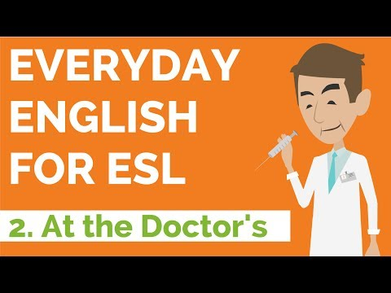

Making an Appointment - Speaking English Conversation (with exercise)
(more advanced)
Link: Making an Appointment - Speaking English Conversation (with exercise)
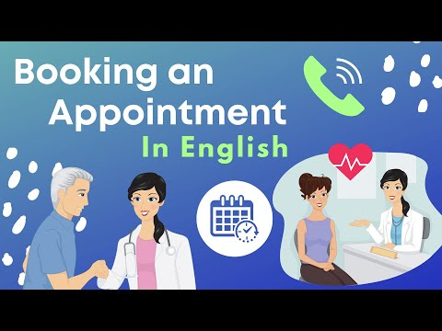

English Vocabulary for visiting the DOCTOR.
Link - English Vocabulary for visiting the DOCTOR
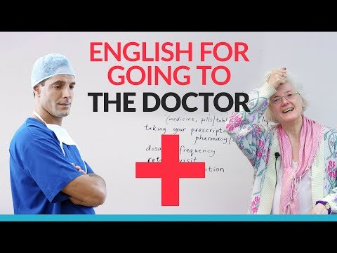
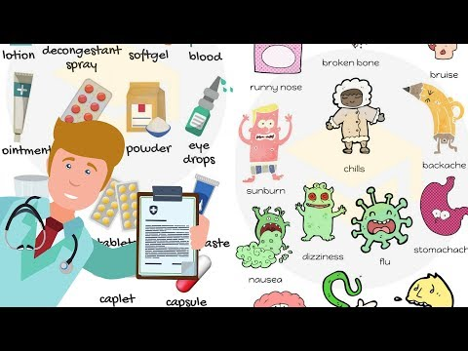

Reference:
NHS website. (2021, February 18). Symptoms of coronavirus. Retrieved 26 February 2021, from https://www.nhs.uk/conditions/coronavirus-covid-19/symptoms/#:%7E:text=If%20you%20have%20any%20of,to%20have%20a%20test.

