Vocabulary Guide:

Going to the supermarket

**A picture containing a surgical, disposable face mask 
What will you to take with you?**

* **A face mask** – In shops you will need to wear a facemask to go in.
* **Hand sanitizer –** it is useful to take this with you so you can keep your hands clean.
* **Money -** This is so you can pay for all your shopping.

|  |  |
| --- | --- |
| **What the coin is worth** | **What the coin looks like** |
| **1p (One Pence)** |  |
| **2p (Two Pence)** |  |
| **5p (Five Pence)** |  |
| **10p (Ten Pence)** |  |
| **20p (Twenty Pence)** |  |
| **50p (Fifty Pence)** |  |
| **£1 (One Pound)** |  |
| **£2 (Two Pound)** |  |
| **What the note is worth** | **What the note looks like** |
| **£5 (Five Pounds)** | A picture of a five pound note   Description automatically generated |
| **£10 (Ten Pounds)** | A picture of a ten pound note   Description automatically generated |
| **£20 (Twenty Pounds)** | A picture of a twenty pound note   Description automatically generated |

* **Shopping bags** – It is useful to take shopping bags with you or you can buy them from the shop.
* **A Shopping List** – This will help you remember all the items you need and it will help with your English.

**Food Labels:**

**What does it mean when food says “suitable for vegetarians” on it? -**

This means the food:

* Does NOT have anything in it resulting from slaughter.
* Only uses free-range eggs.
* No cross-contamination
* Is GMO-free.
* Is not tested on animals.

**What does it mean when food says “suitable for vegans” on it? -**

This means the food is:

* Free from any animal product
* No cross-contamination
* GMO-free
* Not tested on animals

https://vegsoc.org/vegetarian-and-vegan-trademarks/

**What does it mean when food says “gluten free” on it? -**

This means the food contains no gluten.

For more information about gluten free foods watch this video and visit https://www.coeliac.org.uk: [Reading food labels with Coeliac UK](https://www.youtube.com/watch?v=_bU8Zz5YUa4)

**Different kinds of vegetables you will find in a supermarket:**

**Tomato – (a fruit)**

**Leek**

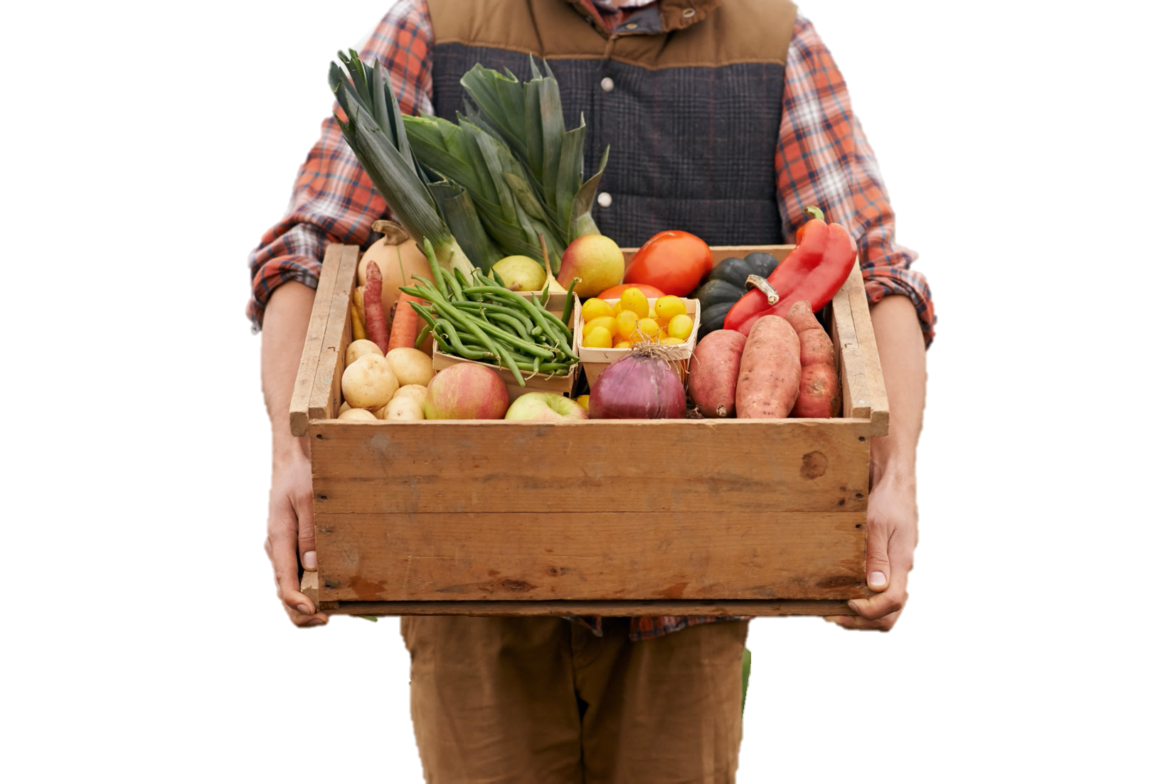

**Green beans**

**Onion**

**Squash**

**Sweet Potato**

**Carrot**

**Potato**

**Pepper**

**Helpful Video:**

Link - [FOOD Vocabulary | Food Names | Types of Food in English with Pictures](https://www.youtube.com/watch?v=Q793ho7TtAA)

**Different kinds of fruit you will find in a supermarket:**

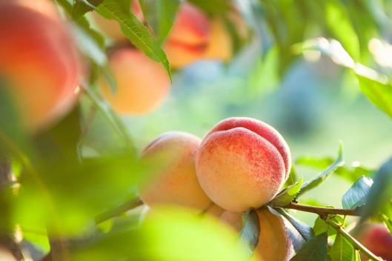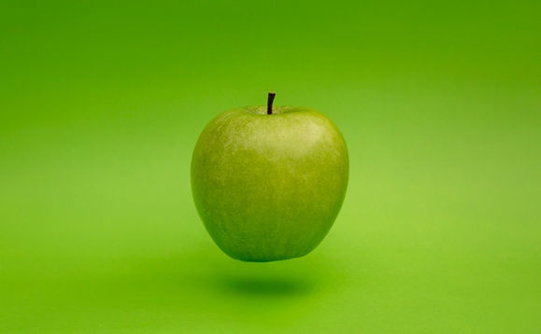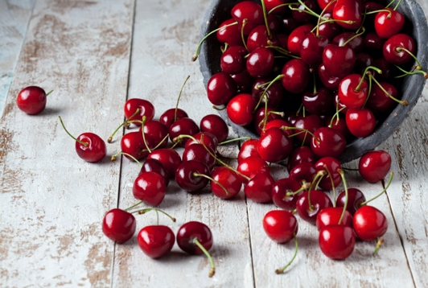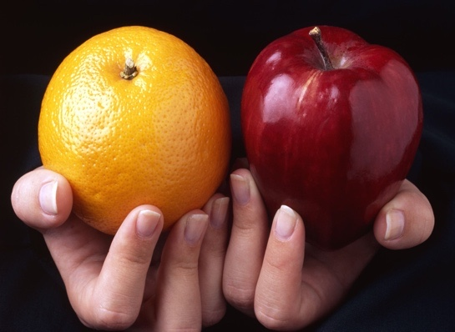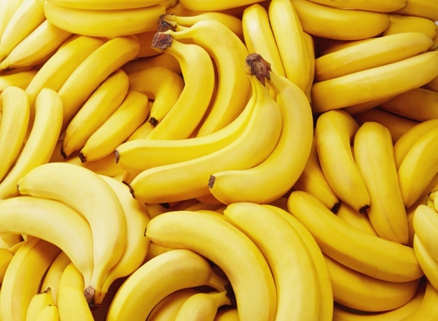

**Orange**

**Banana**

**Apple**

**Cherry**

**Peach**

**Blueberry**

**Raspberry**

**Lemon**

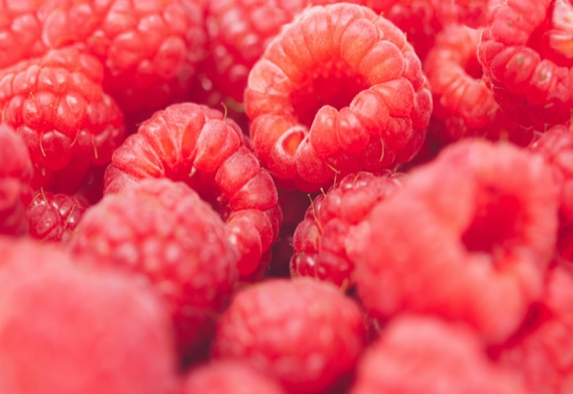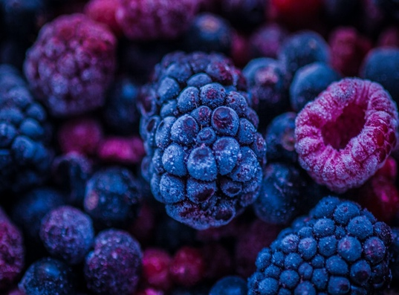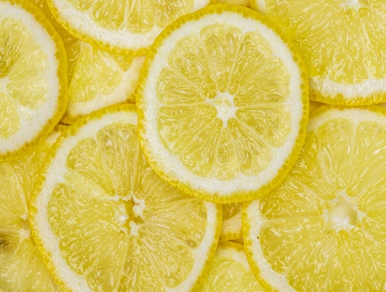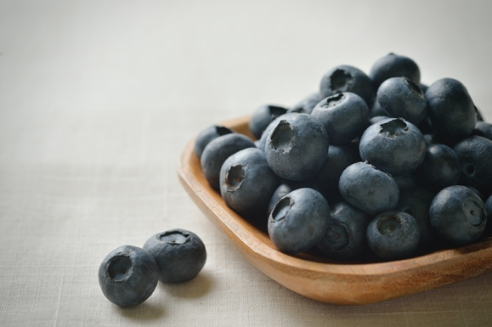

**Blackberry**

**Cleaning products:**

|  |  |
| --- | --- |
|  | Laundry Detergent |
|  | Hand Wash |
|  | Disinfectant spray |
|  | Toilet Paper |
|  | Washing-up Liquid |
|  | Mop and Bucket |
|  | Sponge |
|  | Air freshener |

Reference:

1. The Vegetarian Society. (2020, March 23). The Approved vegetarian and vegan trademarks. Retrieved 26 February 2021, from <https://vegsoc.org/vegetarian-and-vegan-trademarks/>
2. NHS website. (2021, February 18). Symptoms of coronavirus. Retrieved 26 February 2021, from <https://www.nhs.uk/conditions/coronavirus-covid-19/symptoms/#:%7E:text=If%20you%20have%20any%20of,to%20have%20a%20test>.