Duolingo | Website:  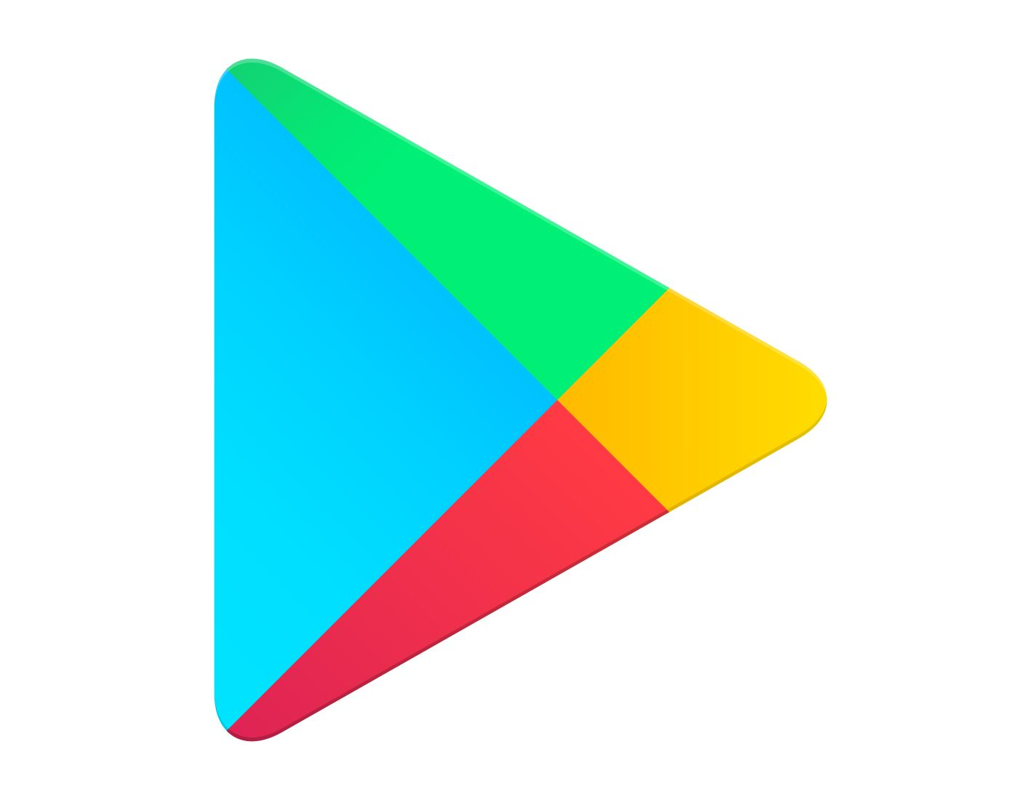  https://www.duolingo.com/ | A popular language learning platform.  Free  With premium services  Accessible to all  Designed like a game but learning like in a class. | Once you download the app it should give you choices of what languages to learn.  (English will be first)  sentences to learn and repeat back.  Chances to take small tests to show improvements in learning.  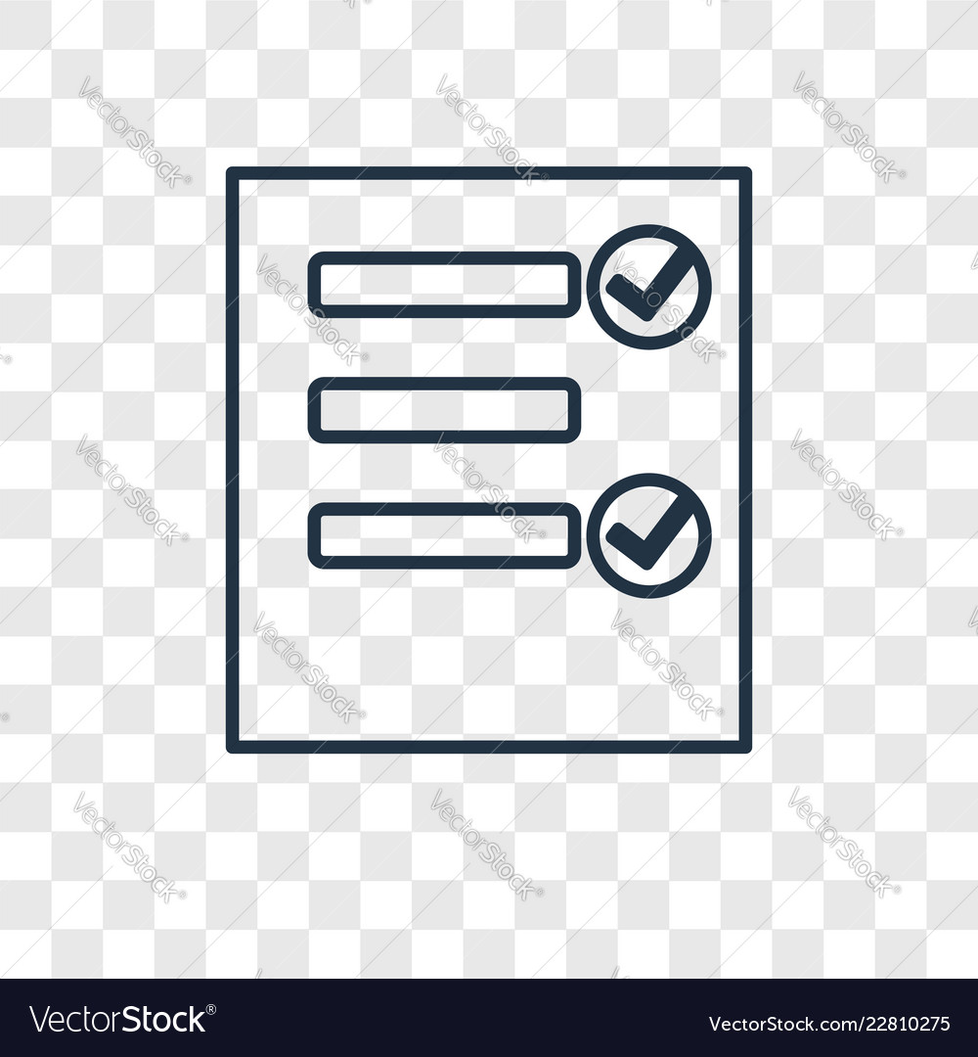  Goals to reach | Personalised learning  Immediate grading  Quick improvement  Tests available
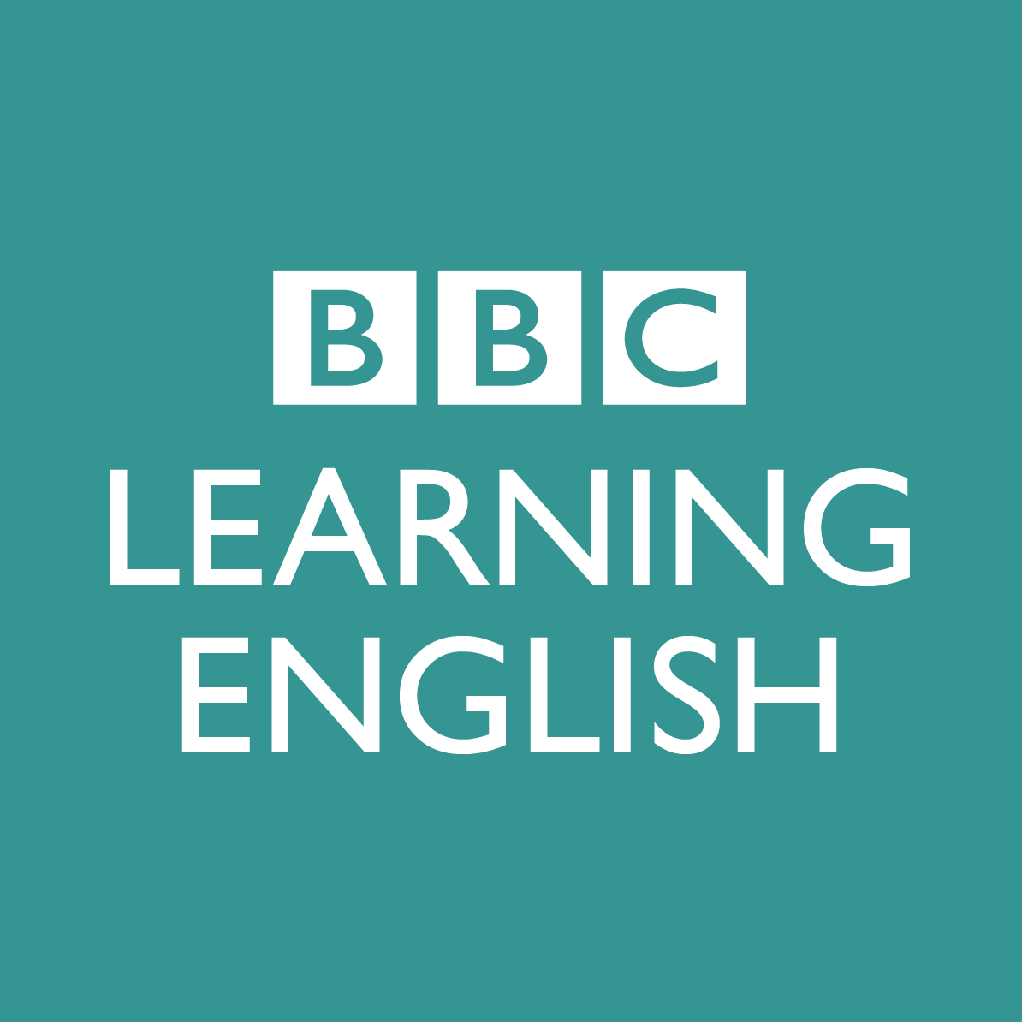  BBC Learning English | Website:  https://www.bbc.co.uk/learningenglish/ | It is a free website and now a free app also.  Offers a wide range of series which helps learners keep their English up to date and improve it.  Includes grammar, pronunciation. | You can either download the app or just go straight to the website online and access different tools they offer to help pick up and learn English.  You can do what you want at your own speed and choose how you’d like to learn. | Wide range of resources and tools.  Videos  Series  Quizzes  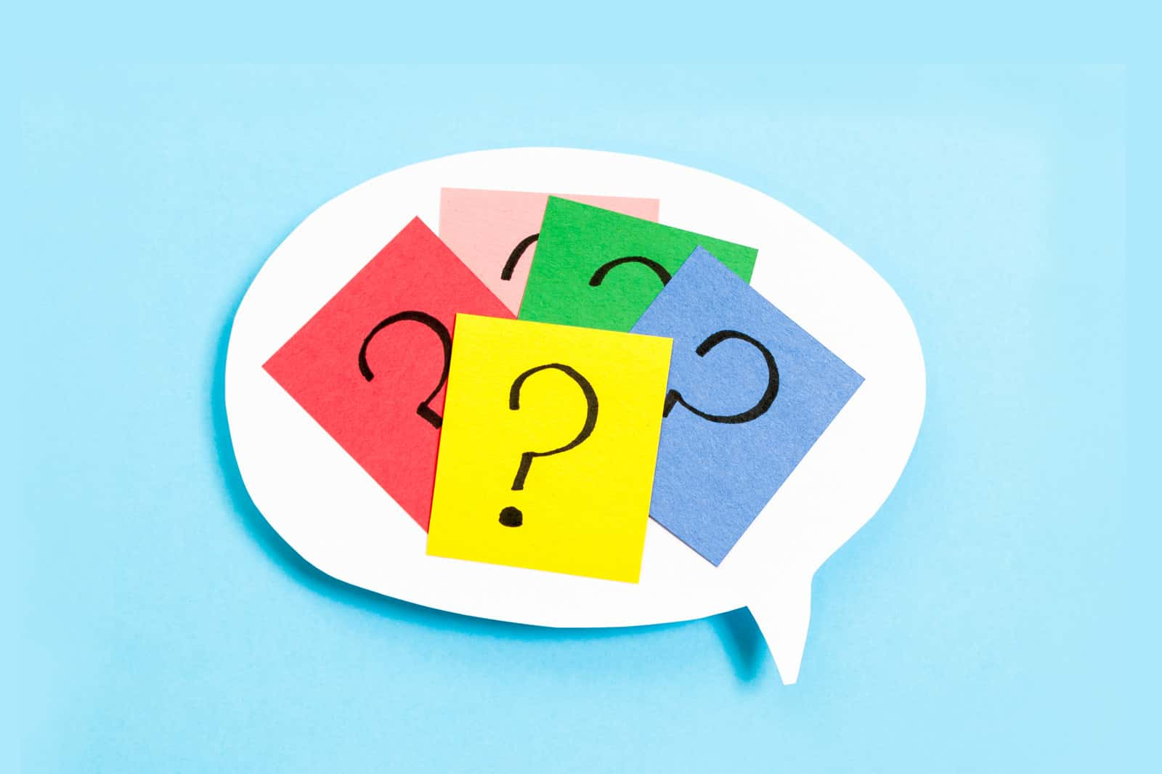  1 minute English lessons.  Vocabulary and grammar practice.
Hello English | App:  https://play.google.com/store/apps/details?id=com.CultureAlley.japa nese.english&hl=en_GB&gl=US | You can learn English and grammar from over 20 languages.  Free app  Offers in-app purchases.  475 interactive lessons  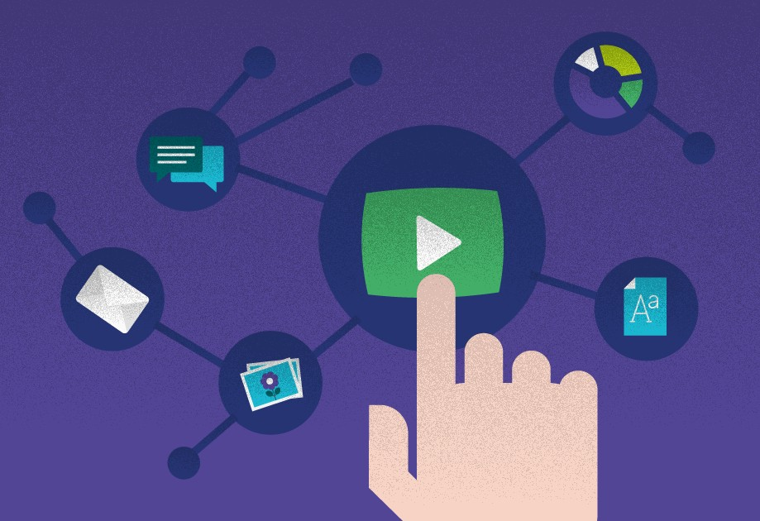  Lessons can work offline also | Download the app and it works essentially the same way as Duolingo.  Pictures with English sentences.  Everyday phrases and sentences. | Interactive lessons and games:  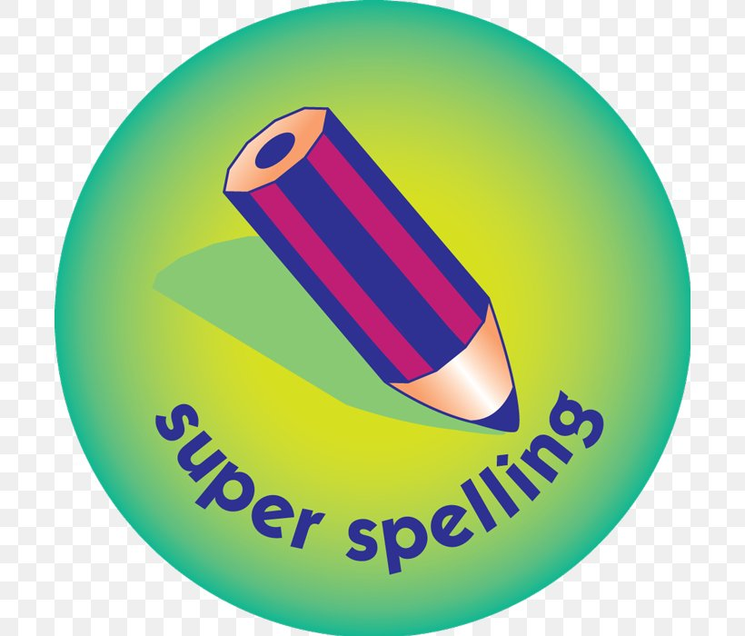  Spelling  Grammar  Vocabulary  Immediate results.

