By Jasmine And Morgan
A Guide to Better Understanding Your Mental Health

Contents

What is Mental Health? Page 2
Early Warning Signs Page 3
Maintaining Mental Health Page 4
How is Well-being Defined? Page 5
Why is Well-being Important? Page 6
Mental Health Myths Page 7 & 8
Looking after your Mental Health Page 9, 10 & 11
What is Mindfulness? Page 12
How does Mindfulness help? Page 13
Guide on how to be more Mindful Page 14
Benefits of sleep Page 15
Methods to help get to sleep Page 16
Types of Sleep Disorders Page 17
How to cope during Lockdown Page 18
Are you struggling during lockdown? Page 19
Some useful links/apps Page 20, 21 & 22

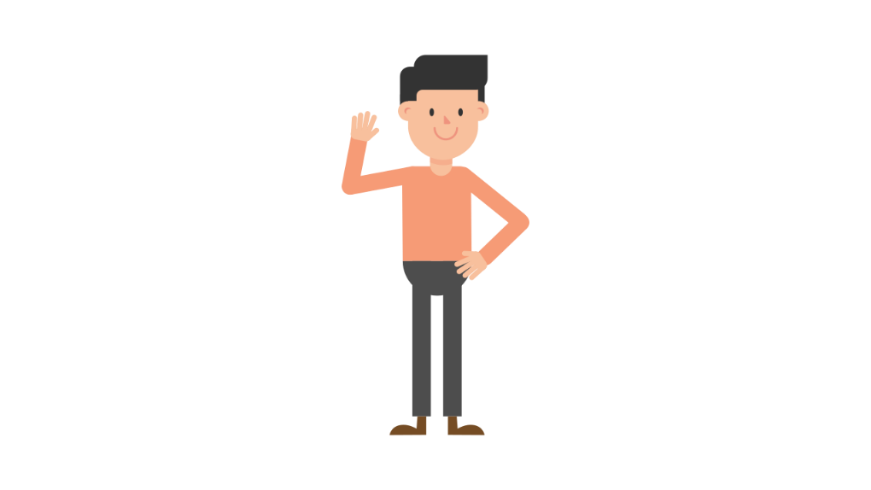
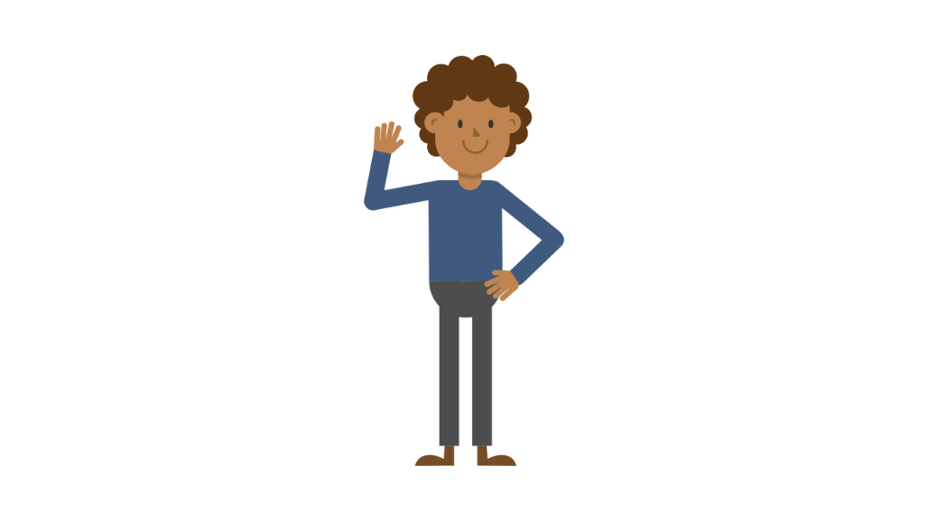
What is mental health?
Mental health includes our emotional, psychological, and social well-being. It affects how we think, feel, and behave. It also helps determine how we handle stress, relate to others, and make choices.

Mental health is important at every stage of life, from childhood to teens and through adulthood.
Over the course of your life, if you experience mental health problems, you are thinking, mood, and behaviour could be affected. Many factors contribute to mental health problems, including:
- Biological factors, such as genes or brain chemistry
Life experiences,
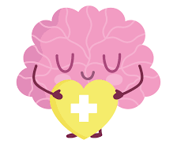

- Life experiences, such as trauma or abuse
- Family history of mental health problems
- Stressful life events, or changes in routine or usual activity

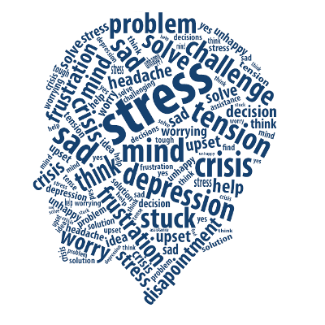
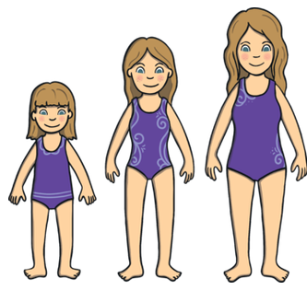

Early Warning Signs
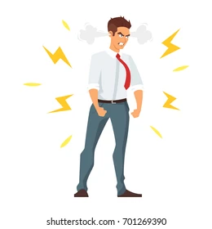
Not sure if you or someone you know is living with mental health problems?

Experiencing one or more of the following feelings or behaviours can be an early warning sign of a problem.

- Eating or sleeping too much or too little
- Pulling away from people and usual activities
- Having low or no energy
- Feeling numb or like nothing matters
- Having unexplained aches and pains
- Feeling helpless or hopeless
- Smoking, drinking, or using drugs more than usual
- Feeling confused, forgetful, on edge, angry, upset, worried, or scared
- Yelling or fighting with family and friends
- Having severe mood swings that cause problems in relationships
- Having constant thoughts and memories you can’t get out of your head
- Hearing voices or believing things that are not true.
- Thinking of harming yourself or others
- Not able to perform daily tasks like taking care of your kids or getting to work or school
Some ways to maintain positive mental health are:
Some FREE useful websites are:
Kooth https://www.kooth.com/
The Calm Zone https://www.thecalmzone.net/
Samaritans https://www.samaritans.org/
- Getting professional help if you need it
- Connecting with others
- Staying positive

- Getting physically active
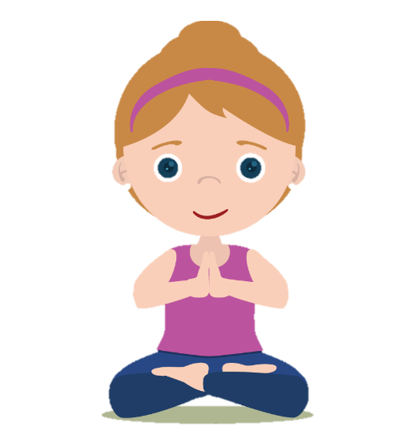
- Helping others

- Getting enough sleep

- Developing coping skills

How is well-being defined?
There is not a single definition of well-being, but it can be described as ‘judging life positively and feeling good’.
Well-being is the state of being healthy, safe, comfortable, and happy.

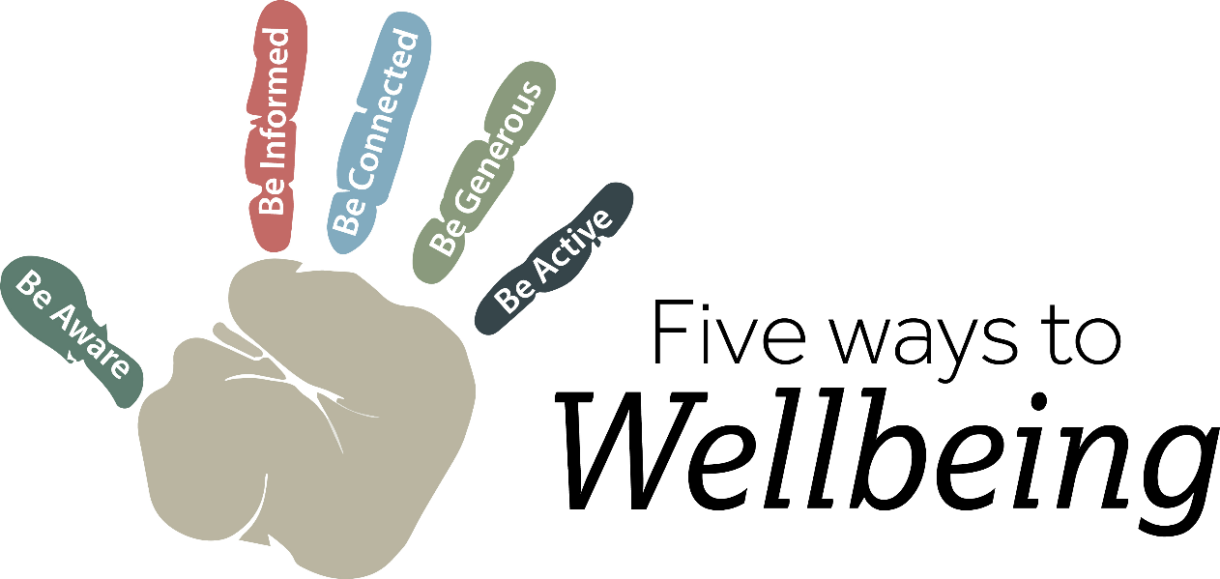

The different aspects of wellbeing are:
- Physical well-being. (Exercise and Health)
- Economic well-being. (Money)
- Social well-being. (Friends and Family)
- Development and activity. (Focusing on you)
- Emotional well-being. (Feelings)
- Psychological well-being. (Mental)
- Life satisfaction. (Happiness)
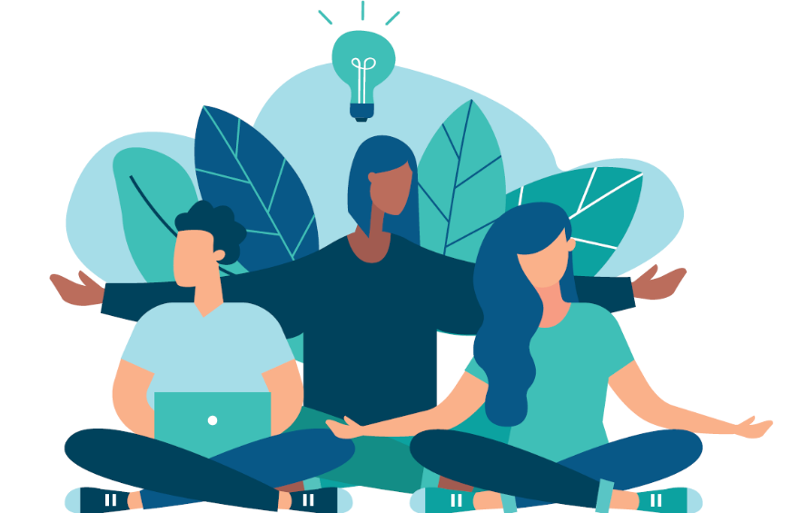
- Engaging activities (Hobbies or Interests)
- Work Fulfilment (Purpose in the workplace)

Why is wellbeing important?
Well-being is associated with many health, job, family, and finance related benefits.

For example, higher levels of well-being are associated with less risk of disease, illness, injury, and longer life expectancy.
People with high levels of well-being are more productive at work and are more likely to contribute to their communities.

Wellbeing is also associated with:
- Self-perceived health (Happiness)
- Longevity (Life expectancy)
- Healthy behaviours (e.g., Exercise)
- Mental and physical illness
- Social connectedness (Friends and Family)
- Productivity (Ability to work well)
- Factors in the physical and social environment

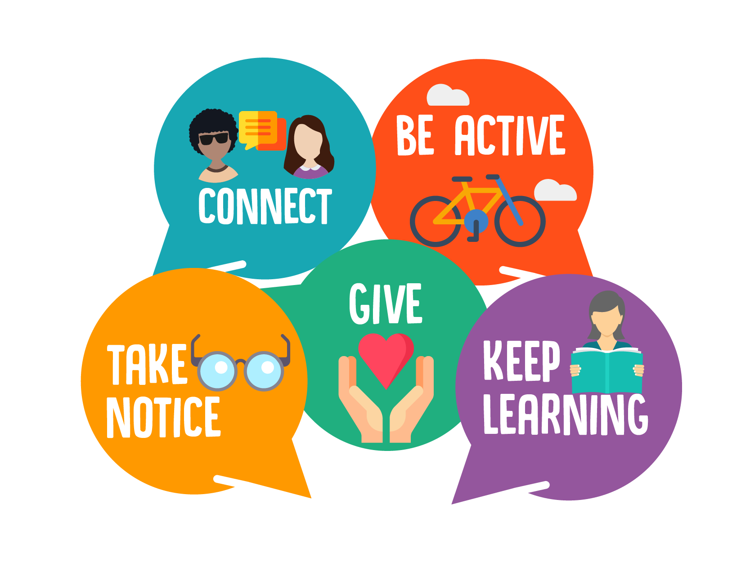

Some Mental Health Myths

(a myth is a widely held but false belief or idea).

Myth: Children don't experience mental health problems
Fact: Even young children may show early warning signs of mental health concerns. These mental health problems can be caused through mental, social, and biological factors.
Half of all mental health disorders show first signs before a person turns 14 years old, and many mental health disorders begin before age 24.
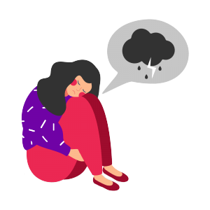
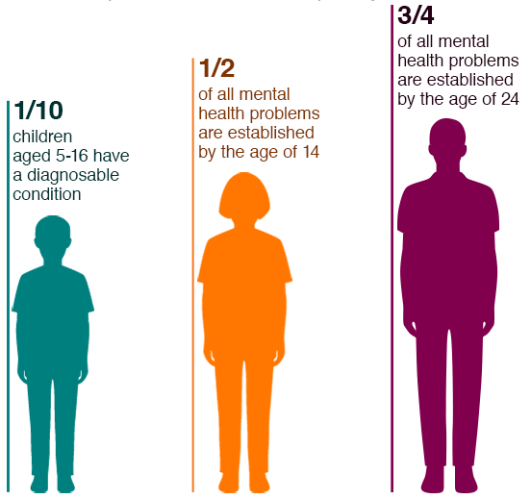
Less than 20% of children and adolescents with treatable mental health problems receive treatment.
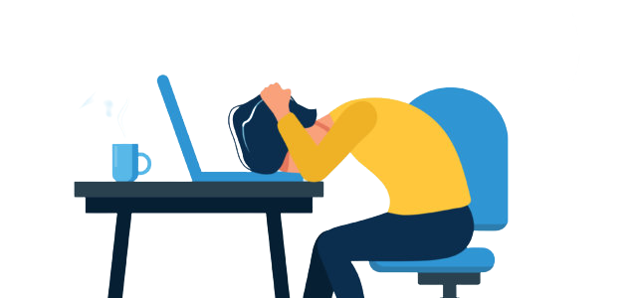

Myth: Personality weakness or character flaws cause mental health problems. People with mental health problems can snap out of it if they try hard enough.
Fact: Mental health problems have nothing to do with being lazy or weak and many people need help to get better. Many factors contribute to mental health problems, including:
Biological factors, such as genes, physical illness, injury, or brain chemistry
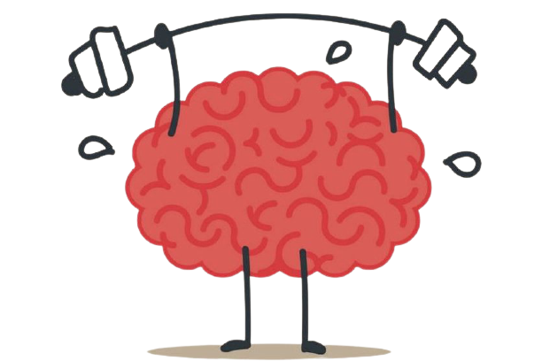
Life experiences, such as trauma or a history of abuse
Family history of mental health problems

Myth: There is no hope for people with mental health problems. Once a friend or family member develops mental health problems, he or she will never recover.
Fact: Studies show that people with mental health problems get better and many recovers completely. Recovery refers to the process in which people can live, work, learn, and participate fully in their communities.
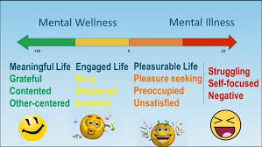

Myth: I can't do anything for a person with a mental health problem.
Fact: Friends and loved ones can make a big difference. Friends and family can be important influences to help someone get the treatment and services they need by:
Reaching out and letting them know you are available to help
Helping them access mental health services
Learning and sharing the facts about mental health, especially if you hear something that isn't true
Treating them with respect, just as you would anyone else
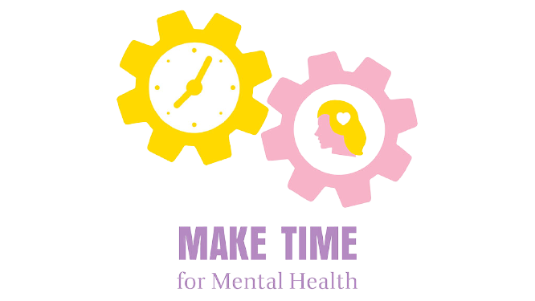
Refusing to define them by their diagnosis or using labels such as "crazy"
More than 60% of people with mental health problems and illnesses won’t seek help that they need. This is because of the stigma around mental illness. If you notice your friend/partner/family member acting different, check on them!

How to be in more control of your mental health

- Manage your stress levels
If you feel you are dealing with lots of things that are making you feel stressed, have a look at some time-management exercises, or ways to reduce your stress levels.
Try to do regular exercise and leave time to yourself. By taking control of your time this can reduce your stress levels very efficiently.
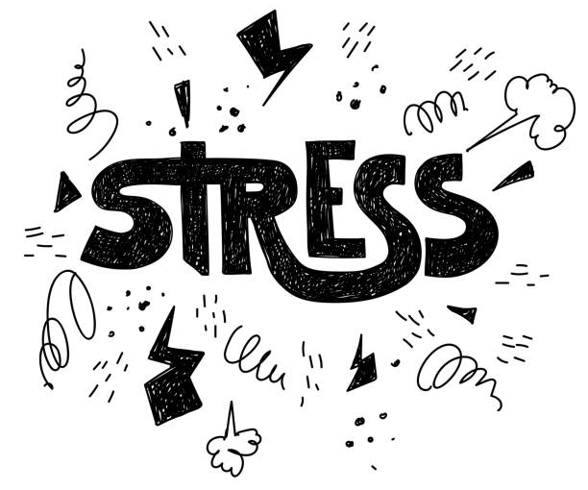
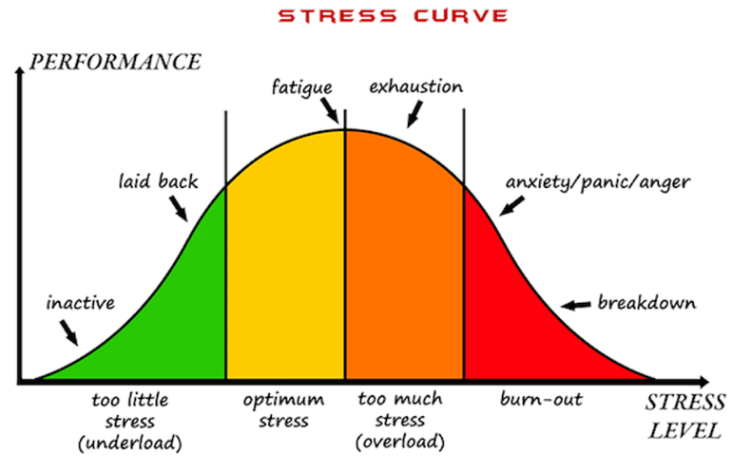
If you feel anxiety during stressful times you can try breathing techniques to calm down and feel more relaxed about the situation.

- Doing things for yourself
By taking the time to do things you enjoy helps with your emotional wellbeing. Such as watching sports with a friend, having a bath, or meeting up with friends can improve your day.
Also doing something you are good at is proven to increase happiness, such as cooking, singing, or painting. These give a sense of achievement to someone after completing it, and therefore improving your overall mood.
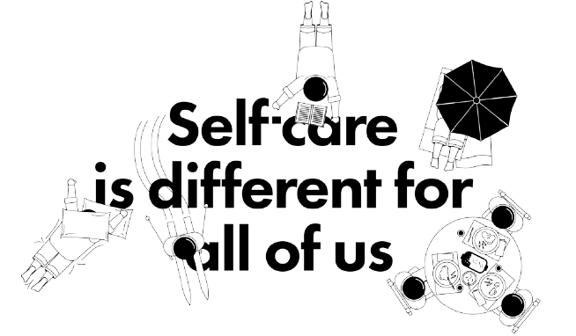
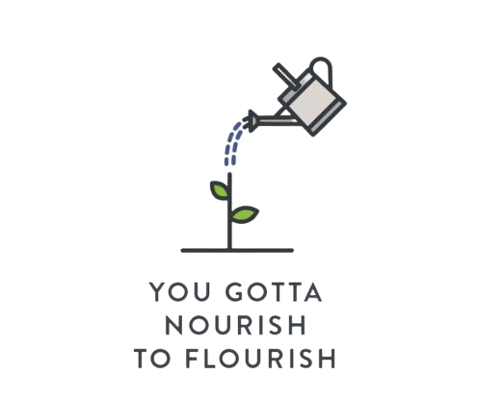
Try to avoid things that seem enjoyable at the time but afterwards you might feel worse such as junk food or impulses like spree shopping.

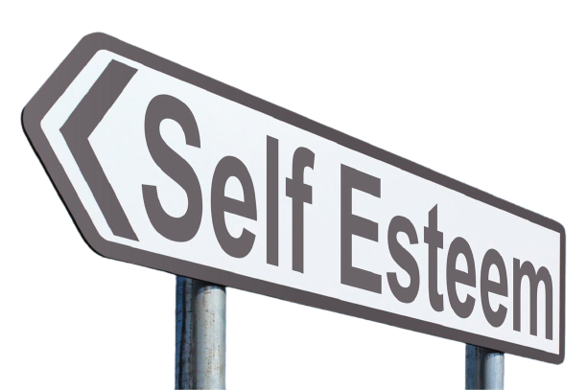
- Self-esteem levels
Self-esteem is the way you feel about yourself.
The best way to improve your self esteem is to treat yourself as you would treat a friend, in a positive but honest way.
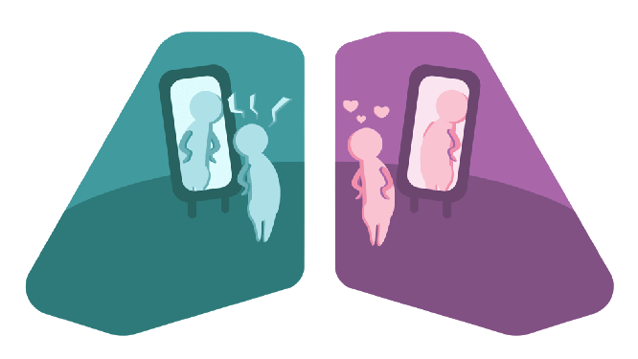
Try to notice when or if you put yourself down and instead think ‘would I think this/say this to a friend?’ and try to tell yourself something positive instead.

- Having a healthy lifestyle
Having and maintaining a healthy lifestyle is important to overall health, by doing things such as a well-balanced diet, exercising and self-care.
Making healthy choices about your diet can make you feel emotionally stronger. A good diet helps your brain and body work efficiently, too. Aim to have a balanced diet that includes all the main food groups.
Moderate exercise releases chemicals in your brain that lift your mood. It can help you sleep better, have more energy and keep your heart healthy. Choose an exercise that you enjoy. If it helps, do it with a friend or listen to music.
Sleep is important to maintaining a healthy body and mind. Around 7 to 8 hours is the average amount of sleep an adult need for their body and mind to fully rest.

- Talk and share your problems
Communication is important, whether it is with a friend, family member or counsellor.
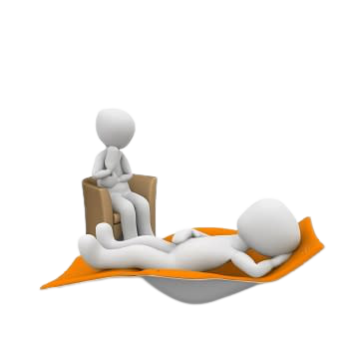
Talking things through helps you to release tension, rather than keeping it inside. It helps strengthen your relationships and connect with people.
Lots of people find talking to a counsellor about things that are troubling them helpful.

- Build Resilience
Resilience is what allows you to cope with life's ups and downs.
Making something worthwhile out of painful times helps your resilience grow.
Being part of a support group, or making something creative out of bad experiences by, for example, writing, painting, or singing, can help you express pain and get through hard times.
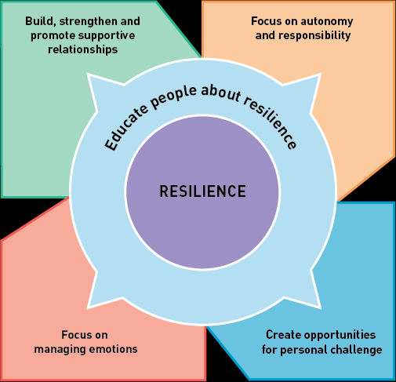
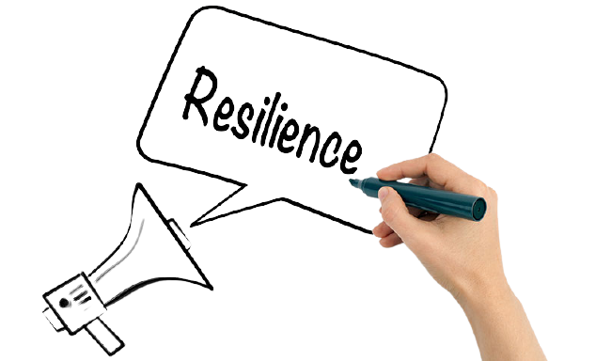
What is Mindfulness?

Mindfulness can help us enjoy life more and understand ourselves better. You can take steps to develop it in your own life.
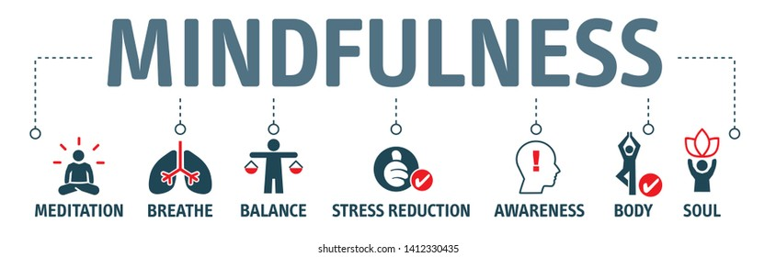
Paying more attention to the present moment – to your own thoughts and feelings, and to the world around you - some people call this awareness "mindfulness".

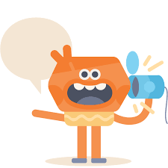
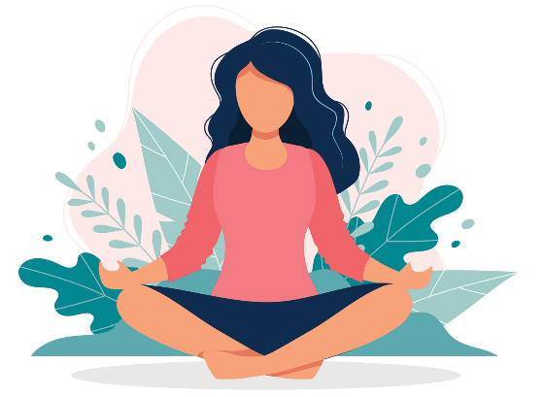
Mindfulness means knowing directly what is going on inside and outside ourselves, moment by moment.
It is easy to stop noticing the world around us and to end up living 'in our heads'.

We often end up caught up in our thoughts without stopping to notice how those thoughts are driving our emotions and behavior.

An important part of mindfulness is an awareness of our thoughts and feelings as they happen moment to moment. It is about allowing us to see the present moment clearly. When we do that, it can positively change the way we see ourselves and our lives.
How does mindfulness help mental wellbeing?
When we become more aware of the present moment, we begin to experience afresh things that we have been taking for granted.
Mindfulness allows us to become more aware of our thoughts and feelings that we experience and to see how we can become too focused on certain things.
Mindfulness is recommended by the National Institute for Health and Care Excellence (NICE) to prevent depression in people who have had 3 or more bouts of depression in the past.

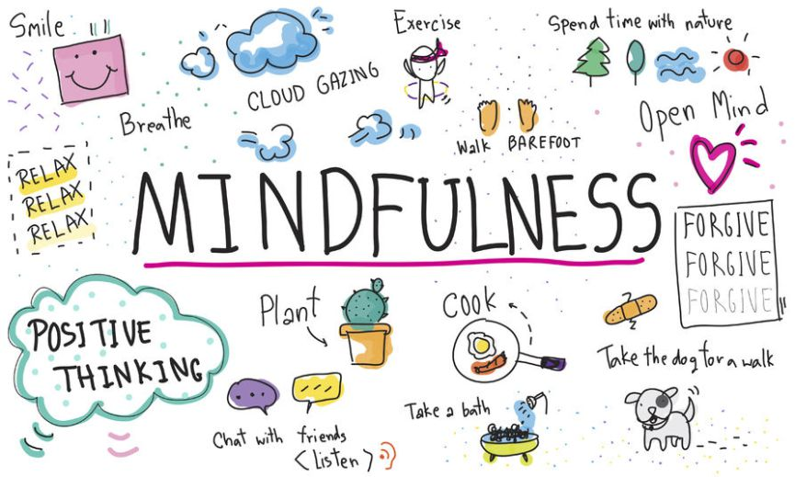
We can ask: 'Is trying to solve this by thinking about it helpful, or am I just getting caught up in my thoughts?’

Is mindfulness helpful for everyone?
Mindfulness is not the answer to all problems, and it is important to acknowledge this. However, it is known to improve many aspects of life if someone actively includes mindfulness practices in their daily activities, and it can be incorporated as little or as much as a person would like, to best benefit them.
Each person has techniques they prefer or activities they like to do to better understand themselves or the world we live in. This allows us to form deeper connections and find better meanings in life.

How to be more mindful
Reminding yourself to take notice of your thoughts, feelings, body sensations and the world around you is the first step to mindfulness.

- Noticing the small things
Through daily life we notice things such as the food we eat, smells down the street or the way other people walk. By taking more notice of the world around us it allows us to have a wider and more in-depth perspective on life.
- Trying new things
Trying new things, such as sitting in a different seat in meetings or going somewhere new for lunch, can also help you notice the world in a new way.
- Watching your thoughts
Lots of people find it difficult to practice mindfulness. As soon as they stop doing something, lots of thoughts and worries can tend to creep in. We cannot take away the thoughts, but we can recognize that they come and go and experiencing these feelings will not be forever.
- Naming thoughts or feelings
To develop an awareness of thoughts and feelings, some people find it helpful to silently name them: "Here's the thought that I might fail that exam". Or "This is anxiety".
- Free yourself from the past and future
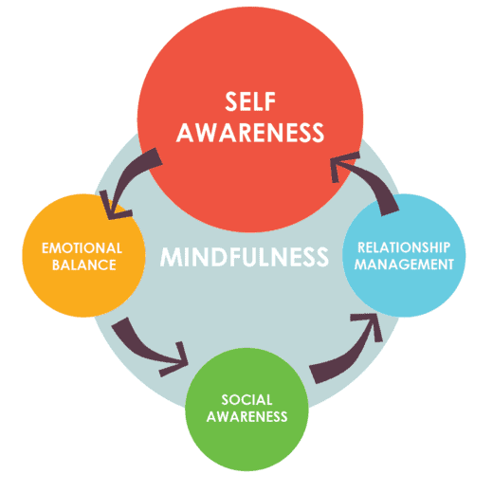
You can practice mindfulness anywhere, but it can be especially helpful to take a mindful approach if you realize that, for several minutes, you have been "trapped" in reliving past problems or "pre-living" future worries.

Headspace is a great mindfulness app, it comes free with any plan of Spotify premium, and a 7-day free trial. They also have student and family discounts.
Sleep
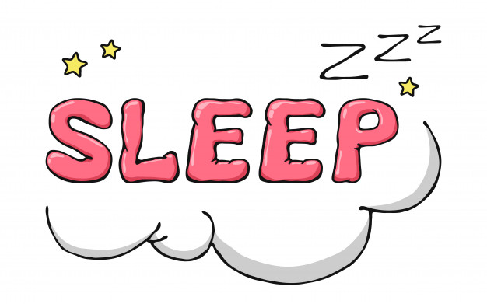
Sleep is essential for humans to function and to be able concentrate throughout the day. It allows us to be productive and have a better immune system to help fight disease/illness.

Benefits of sleep:
Decreases stress levels
Better mental health and mental state as well as physical state
Keep and maintain a healthy weight
Get on better with people and have better relationships (e.g., family and friends)
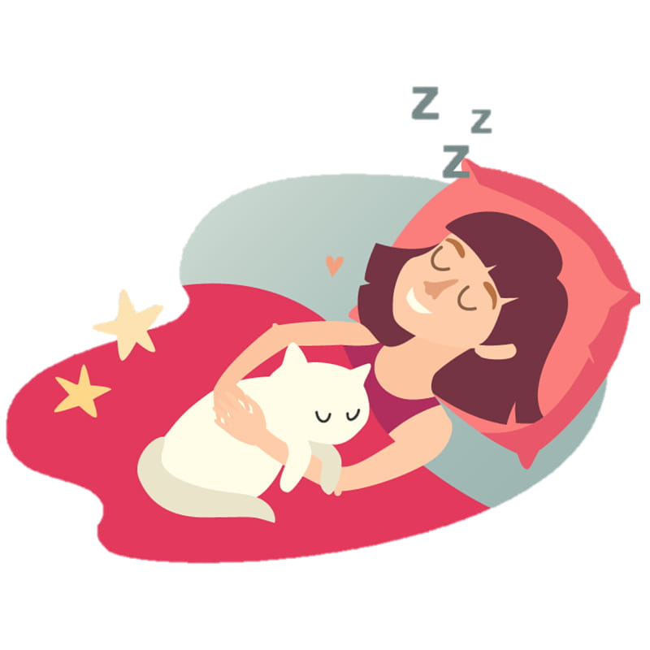
Improves mood level and happiness within self and others around you
Strengthens the heart and mind, as needed repair happens inside the body as you sleep.
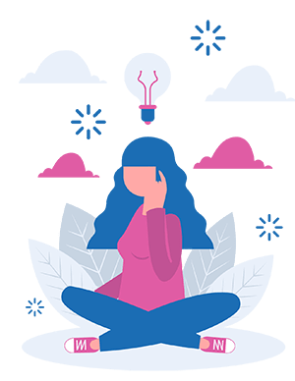

With Me in Mind Rotherham Sleep talk:
https://www.youtube.com/watch?v=h2co9JRkJys
Methods to help when getting to sleep:
If you are struggling to get to sleep or have trouble getting a full night's sleep, there are some methods to help this:

- Try to get in bed at the same time every day and keep the same amount of sleep each night.
- Try and relax before bed, read a book, or have a bath.
- Make sure your bed is comfortable.
- Try to exercise at least once a day e.g., going on a walk, run but try not to exercise a couple of hours before bed.
- If you cannot sleep do not sit in bed and worry, get up and do something that will relax you.
- Do not bring any worries to bed with you try and think in another room so that your bed is not associated with overthinking and worrying.
- Practice yoga, meditation, and mindfulness. Yoga will help with breathing and relieve tension throughout the body. Mindfulness will allow you to forget about your worries and relax your mind.
- Avoid naps during the day as you won’t then feel tired at night.
- Turn off mobile phones, tv, video games. Using these will keep your mind active taking longer to relax.
- Try using sleep sprays that can be sprayed on your pillow and will relax you. A common one used is lavender.
- Visualise things that make you happy for example, seeing your friends.

A Meditation You-Tube video: https://www.youtube.com/watch?v=aEqlQvczMJQhttps://www.youtube.com/watch?v=aEqlQvczMJQ

Is Lockdown affecting our sleep?
https://www.bbc.co.uk/news/av/uk-england-hampshire-52322502

Sleep disorders:
Sleep disorders involve problems with the quality, timing, and amount of sleep, which result in daytime distress and difficulty to function.
They often happen along with medical conditions or other mental health conditions, such as depression or anxiety.

Insomnia: Is the inability to get to sleep or to have a night of continuous sleep.

There are two types of insomnia:
Short term insomnia can occur after a stressful life event.
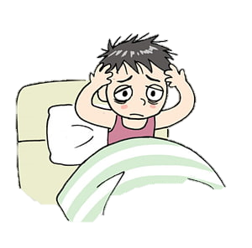
Chronic insomnia may occur when you struggle to sleep for a month or longer, you feel tired throughout the day.
Reasons you may develop insomnia:
- Medical conditions
- Disrupted sleep-wake schedule
- Poor sleep hygiene
- Sleep related breathing disorders
Some symptoms of insomnia:
- You can’t sleep even when you’re tired
- You can’t enough sleep to feel like you’ve rested
- Have restless sleep

Some other sleep disorders:
Excessive sleepiness: if you struggle with sleep talking/walking or grinding your teeth in sleep this may result in needing to sleep in the day.

Parasomnia: sleep walking, nightmares.

Shift work sleep disorder: trouble sleeping when working night shifts or changing shift patterns.

The link below gives four different ideas that you may wish to try to help you to fall asleep fast.
https://www.youtube.com/watch?v=-OQlcK-z2Xw
How to cope during the current lockdown:
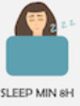
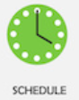
During this global pandemic, many people have found it hard mentally with not being able to see friends and family and be able to socialise.

If you feel that you are struggling, there are some ideas here to help!
- Get outside in the fresh air whether it's a run, a walk, working outside. Take photos of nature and be creative! Going outside will help to get minds active and to be positive.
- Allow time to work but also to rest and unwind.
- Make sure you have social support. Communicate with teachers, friends, and family. Whether it's on a call, zoom or facetime.
- Focus on the present, not the past or future. Do things that make you happy, maybe listen to your favourite music or watch your favourite movie.
- Have a routine: try to set yourself a challenge every day that you can achieve no matter how big or small the task is. A sense of achievement will allow you to feel positive.
- Give yourself a reason to get up in the morning. Getting up every day and getting through it will improve happiness.
- Send a letter or do something for someone you know or care about. This will make them feel better and you’ll feel accomplished.
- Try to have a regular sleep routine.
How to spot if your mental health is declining in lockdown:
The coronavirus pandemic has been a worrying, lonely and tough time for a lot of people.
It is so important to talk with others and be open about any mental health problems.
45% of people have said that their mental health has worsened.

New mental health problems have developed due to the pandemic and many ongoing have worsened.
The main cause for this is not seeing people, not going outside, boredom because of the national and local lockdowns and anxiety about getting the coronavirus.

If you have tried all of these and are still feeling low and maybe anxious there are many places where you can seek help from:
- Arrange a doctor’s appointment.
- Samaritans are always available by calling 116 123. If you struggle to speak to someone there is also an email you can communicate with: jo@samaritans.org
‘MIND’ offers mental health support between 9am and 6pm on a monday-friday. This link provides information on accessing treatment, ways to cope, wellbeing etc. https://www.mind.org.uk/information-support/coronavirus/
Websites you may wish to use:

How to sleep better
- https://www.mentalhealth.org.uk/publications/how-sleep-better

NHS sleep guide
- https://www.cambridgeshireandpeterboroughccg.nhs.uk/easysiteweb/getresource.axd?assetid=11887&type=0&servicetype=1

Sleep disorders
- https://www.healthline.com/health/sleep/disorders#diagnosis

A service providing support for those struggling with their mental health.
- https://www.mind.org.uk/

The Campaign Against Living Miserably (CALM) is leading a movement against suicide. They offer a free and confidential helpline and webchat, 7 hours a day, 7 days a week for anyone who needs it.
- https://www.thecalmzone.net/

The Mental Health Organization website has a section dedicated to better understanding your mental health, statistics, and an A-Z list of all mental health issues a person could have.
- https://www.mentalhealth.org.uk/your-mental-health
Papyrus is a charity aimed at ‘shattering the stigma around suicide and equipping young people and their communities with the skills to recognize and respond to suicidal behavior’. They have a helpline that is open 9am – 12am 365 days a year contactable by phone or email. (called HOPELINEUK).
- https://www.papyrus-uk.org/

A FREE service for people struggling with their mental health or someone who is worried about someone they know. You can contact them by phone, email, the self-care app, writing a letter or going to one of their branches throughout the UK.
- https://www.samaritans.org/

A FREE service for women and girls for those who need emotional support after experiencing sexual violence. This is a one-to-one Live Chat Helpline, which is confidential.
- https://rapecrisis.org.uk/

The UK’s leading charity in fighting for children and young people’s mental health. Text the YoungMinds Crisis Messenger for free 24/7 support across the UK if you are experiencing a mental health crisis. If you need urgent help, text YM to 85258.
- https://youngminds.org.uk/

An Online mental health and wellbeing community. Free, safe, and anonymous support.
- https://www.kooth.com/

The Mix is a UK support service for young people. They can help with a wide range of issues such as mental health to money, homelessness to finding a job. You can contact them through their FREE confidential helpline or their counselling service.
- https://www.themix.org.uk/

An online mental health forum specifically for men, with FAQs about a multitude of issues men might face.
- https://www.menshealthforum.org.uk/howru-hub

Childline is here to help anyone under 19 in the UK for FREE 9am- 3:30 am every single day. Their service is private and confidential, and you can talk about anything.
- https://www.childline.org.uk/

Textcare is designed to provide emotional support at the times a person needs it most. They provide a one-way message directly to your phone. This is a confidential service for those aged 16 and over, and each message will be individually written for you based on the information you write into their Textcare form.
- http://www.sane.org.uk/textcare

If you need support for a violent, abusive, or controlling relationship, refuge is here to help. You can call their national domestic abuse helpline for free 24 hours a day. You can also chat to their volunteers online, Monday to Friday.
- https://www.refuge.org.uk/ &
- https://www.nationaldahelpline.org.uk/

If you have been affected by crime, Victim Support can give you the support you need to move forward. Their services are free, confidential, and available to anyone in England and Wales, regardless of whether the crime has been reported or how long ago it happened.
- https://www.victimsupport.org.uk/

Apps you may wish to use:
- Calm: meditation and sleep: this app provides you with things such as sleep stories to help you fall asleep, music to help focus, relax, and sleep.
- Sleep: similarly, to calm this app also provides stories to help you sleep, meditations to improve mindfulness and help with stress and anxiety and a bedtime reminder to help you maintain a sleep pattern.
- Daylio journal: this app allows you to set goals for yourself daily, weekly, and monthly It helps record your moods helping you to take care of your mental, emotional, and physical health.
- Daily calm: Meditation and sleep: This helps you to focus, breathe, meditate, sleep, and relax. There are 12 categories within the app including relaxation, yoga, self-care, concentration, and emotions. This app does have a free trial and then may include a monthly cost.

