5 yoga poses:

Tree pose:  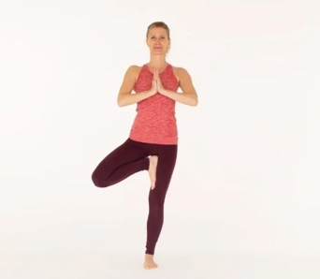 | - Step 1: Bring your palms to face each other in a prayer position.  - Step 2: Be sure that your right foot is firm to the floor.  - Step 3: Bend your left knee forward and then out to the side.  - Step 4: take the sole of your left foot and bring it up to your inner thigh.
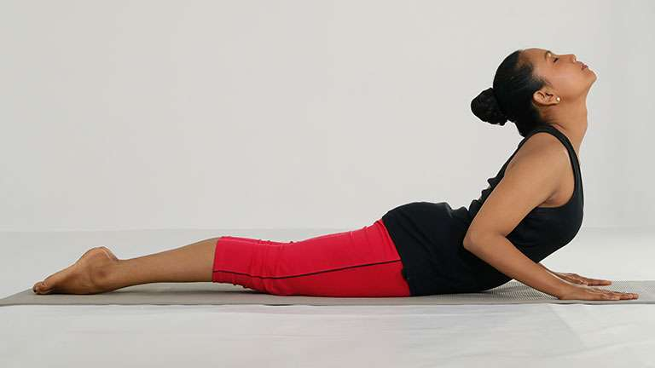  Cobra: | - Step 1: Lay on your stomach with your chin up.  - Step 2: Place your hands on the floor, below your shoulders with your elbows pointing straight up to the sky.  - Step 3: Bring your legs and inner thighs together.
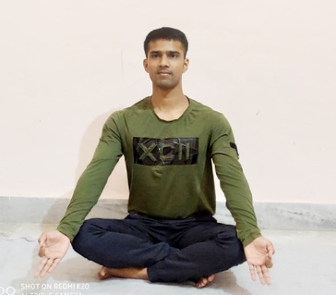  Easy pose (Sukhasana): | - Step 1: Cross your legs with your feet and little toes resting gently on the ground.  - Step 2: Roll your shoulders back and raise your chest to the sky, stretching out your torso and spine.
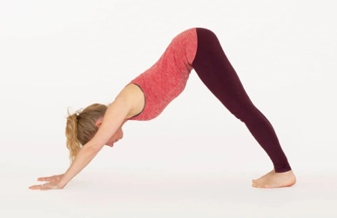  Downward facing dog: | - Step 1: Place your hands shoulder-width distance apart  - Step 2: make sure your knees and feet are hip-width distance apart.  - Step 3: Tuck your toes under, lift hips high and reach heels low. You will now be in a forward bend position.
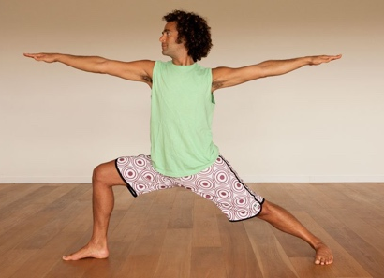  Warrior 2: | - Step 1: Step your left foot back into a lunge position, keeping your right foot in place  - Step 2: Spin your left heel round on the floor, your right heel should be in line with your left arch.  - Step 3: Open your arms straight out at shoulder height.

